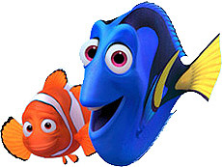Finding Nemo

1. In the beginning, in which seafloor feature do Coral and Marlin live?
2. Why do you think it would be dangerous to live near the “drop off”?
3. Name at least 5 organisms that live where Nemo lives.
4. What type of ecosystem does Nemo live in? (Hint: Mr. Ray asks Nemo.)
5. When Nemo is captured by the humans, Marlin swims after him. What sea floor feature does Marlin swim down to in order to get help?
6. What features on Dory’s body allow here to say, “I am built for speed!”?
7. In the coral reefs it was very bright and colorful, but at the bottom it was gray and dull. Why is this?
8. Explain the effect of the smell of blood on sharks. Why do you think this happens?
9. When Dory and Marlin wake up after the shark “attack,” the mask is lost in the dark abyss. Why would it not be possible for Dory and Marlin to survive down there (Name at least 2)?
10. What type of fish “helps” Dory read the mask?
11. What type of deep sea adaptation does this organism have?
12. When Nemo is in the fish tank for the first time, name the type of fish in the aquarium.
13. In the scene where Marlin get’s upset at Dory for repeating the address over and over, they run into a school of fish. What is the benefit for swimming in a school of fish?

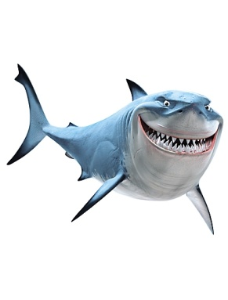

1. Dory and Marlin are supposed to swim ___________ the trench. What is wrong with the trench in the movie versus a real trench we have been studying?
2. Name the current that Dory and Marlin ride? Do you *think* it is a warm or cold current?
3. While in Sydney the water is very shallow in the bay. What sea feature is this? What animals live there?
4. What environmental (good or bad) impact do the manmade structures (boats, pipelines, etc.) bring to the ecosystem there?
5. Think back through the movie. Name all the sea floor features that Marlin went to, and describe 3 new facts about the features you didn’t know about before. Then name 2 things you found interesting from the whole movie you didn’t know about before, and ask 1 question you have about the sea floor features.